A sorting algorithm is an algorithm that will put elements if a list in a specific way/order. One of the most common orders is the numerical order and also lexicographical order.

**Linear Search**

This is one of the simplest forms of a sorting algorithm. In this sorting method what it does is it finds a particular value in a list and then checks every one of the elements in the sequences all the way till the desired element has been found or all the way until the list has got exhausted.

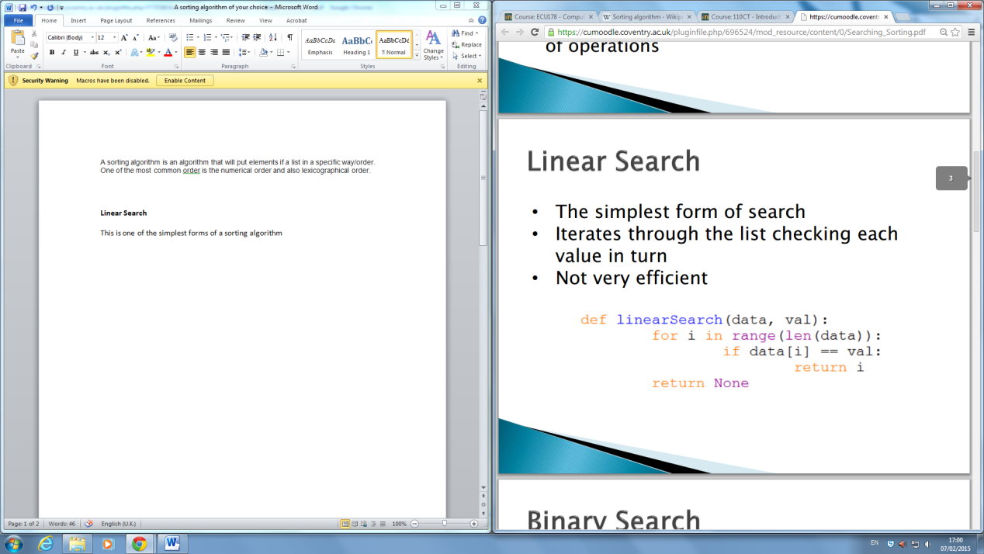

This is one example of linear sorting that was giving in one of my university classes.

This algorithm checks all of the elements of the array, It does this one by one and also in a sequence until the result which it was searching for has been found.

Linear search is known to be one of the most basic of them all of sorting and search algorithms.

**Reference**

<https://cumoodle.coventry.ac.uk/pluginfile.php/696524/mod_resource/content/0/Searching_Sorting.pdf> 7th February 2015

http://en.wikipedia.org/wiki/Linear_search 7th February 2015

<http://www.slideshare.net/Neoclassical/linear-search-algorithm-29158293> 7th February 2015